This is the supplementary file for the paper entitled A Relaxed Symmetry-Constrained Non-negative Model for Large-Scale Undirected Weighted Network Representation. Some supplementary tables and figures illustrating the experimental results are put in this file and cited in the manuscript.
A Relaxed Symmetry-Constrained Non-negative Model for Large-Scale Undirected Weighted Network Representation: Supplementary File
Yurong Zhong, Xin Luo, Senior Member, IEEE, and Zidong Wang, Fellow, IEEE

Supplementary Tables

TABLE S1. RMSE of M1-8 on D1-6, where ✪ indicates M8 has lower RMSE than the rival model.
No. | M1 | M2 | M3 | M4 | M5 | M6 | M7 | M8✪
D1 | 0.1319±3.8E-4✪ | 0.1333±2.4E-4✪ | 0.1329±9.8E-5✪ | 0.1544±2.6E-4✪ | 0.1574±1.2E-4✪ | 0.1325±2.6E-4✪ | 0.1289±2.4E-4✪ | 0.1280±1.8E-4
D2 | 0.1290±9.4E-5✪ | 0.1330±2.0E-4✪ | 0.1324±4.5E-4✪ | 0.1649±2.7E-4✪ | 0.1813±1.6E-4✪ | 0.1291±1.7E-4✪ | 0.1272±1.0E-4✪ | 0.1261±3.5E-4
D3 | 0.1431±1.5E-3✪ | 0.1437±2.0E-4✪ | 0.1500±1.3E-3✪ | 0.1806±4.1E-4✪ | 0.1972±1.4E-4✪ | 0.1412±2.5E-4✪ | 0.1399±2.3E-4✪ | 0.1389±2.3E-4
D4 | 0.2301±8.6E-4✪ | 0.2559±5.5E-4✪ | 0.3148±8.3E-4✪ | 0.2297±1.3E-4✪ | 0.2369±6.8E-4✪ | 0.2233±9.7E-4✪ | 0.2269±2.2E-3✪ | 0.2215±1.3E-4
D5 | 0.0756±3.6E-4✪ | 0.0821±1.7E-5✪ | 0.1561±8.0E-4✪ | 0.0740±1.2E-5✪ | 0.0764±8.1E-5✪ | 0.0741±2.6E-4✪ | 0.0739±3.7E-4✪ | 0.0728±3.6E-4
D6 | 0.0423±7.7E-5✪ | 0.0464±1.3E-5✪ | 0.0931±4.9E-4✪ | 0.0415±8.5E-5✪ | 0.0430±5.3E-5✪ | 0.0413±7.2E-5✪ | 0.0412±8.1E-5✪ | 0.0409±1.9E-4
✪Win/ Loss | 6/0 | 6/0 | 6/0 | 6/0 | 6/0 | 6/0 | 6/0 | -
Friedman Rank | 4.167 | 6.333 | 6.667 | 5.333 | 7 | 3.333 | 2.167 | 1

TABLE S2. Converging Iteration Count of M1-8 on D1-6, where ✪ indicates M8 has less Converging Iteration Count than the rival model.
No. | M1 | M2 | M3 | M4 | M5 | M6 | M7 | M8✪
D1 | 341±2.87✪ | 187±4.0✪ | 199±7.41✪ | 685±16.71✪ | 1000✪ | 349±2.22✪ | 87±15.87 | 108±7.97
D2 | 192±6.45✪ | 311±5.20✪ | 175±17.90✪ | 975±42.01✪ | 1000✪ | 173±3.41✪ | 93±14.46 | 101±17.86
D3 | 122±5.79✪ | 284±3.24✪ | 205±48.28✪ | 959±29.28✪ | 674±4.28✪ | 118±5.12✪ | 95±11.99 | 118±4.88
D4 | 967±4.76✪ | 40±2.49 | 88±4.15 | 33±0.32 | 69±0.89 | 1000✪ | 39±4.42 | 205±10.35
D5 | 568±5.13✪ | 251±1.22✪ | 77±2.79 | 52±0.55 | 103 | 1000✪ | 44±4.48 | 164±3.42
D6 | 582±2.13✪ | 227±1.26✪ | 51±1.37 | 20±0.45 | 357✪ | 1000✪ | 91±1.67✪ | 81±1.33
✪Win/ Loss | 6/0 | 5/1 | 3/3 | 3/3 | 4/2 | 6/0 | 1/5 | -
Friedman Rank | 5.833 | 4.833 | 3.833 | 4.333 | 6.167 | 5.917 | 1.667 | 3.417

TABLE S3. Time Cost (Sec.) of M1-8 on D1-6, where ✪ indicates M8 has less Time Cost than the rival model.
No. | M1 | M2 | M3 | M4 | M5 | M6 | M7 | M8✪
D1 | 64±2.01 | 349±17.29✪ | 6569±152.57✪ | 1043±30.48✪ | 2287±18.82✪ | 34±2.82 | 67±13.89 | 88±6.55
D2 | 53±4.05 | 2272±38.06✪ | 12197±814.95✪ | 5759±504.90✪ | 9542±980.55✪ | 22±3.41 | 94±16.25 | 112±19.04
D3 | 40±9.7 | 1103±74.94✪ | 48±11.67✪ | 2101±247.69✪ | 2477±131.54✪ | 19±2.91 | 120±29.15 | 178±14.04
D4 | 19±2.51✪ | 109±7.98✪ | 2013±78.62✪ | 80±1.91✪ | 215±3.78✪ | 11±2.09✪ | 2±0.31 | 11±1.02
D5 | 41±7.21✪ | 5879±46.83✪ | 12527±389.87✪ | 872±26.98✪ | 2631±6.11✪ | 50±2.48✪ | 19±0.99 | 48±1.26
D6 | 74±6.61✪ | 18171±115.57✪ | 30029±651.33✪ | 1074±26.41✪ | 30074±128.59✪ | 81±3.54✪ | 44±2.92✪ | 42±1.44
✪Win/ Loss | 3/3 | 6/0 | 6/0 | 6/0 | 6/0 | 3/3 | 1/5 | -
Friedman Rank | 2.5 | 5.833 | 7 | 5.667 | 7.167 | 2.25 | 2.333 | 3.25

TABLE S4. Results of Wilcoxon Signed-Ranks Test.
Comparison | RMSE |  |  | Converging Iteration Count |  |  | Time Cost
Comparison | R+ | R- | p-value | R+ | R- | p-value | R+ | R- | p-value
M1 vs. M8 | 21 | 0 | 0.0156 | 21 | 0 | 0.0156 | 15 | 6 | 0.2188
M2 vs. M8 | 21 | 0 | 0.0156 | 17 | 4 | 0.1094 | 21 | 0 | 0.0156
M3 vs. M8 | 21 | 0 | 0.0156 | 10.5 | 10.5 | 0.5313 | 20 | 1 | 0.0313
M4 vs. M8 | 21 | 0 | 0.0156 | 15 | 6 | 0.2188 | 21 | 0 | 0.0156
M5 vs. M8 | 21 | 0 | 0.0156 | 18 | 3 | 0.0781 | 21 | 0 | 0.0156
M6 vs. M8 | 21 | 0 | 0.0156 | 15 | 0 | 0.0313 | 12 | 3 | 0.1563
M7 vs. M8 | 21 | 0 | 0.0156 | 19 | 2 | 0.0469 | 20 | 1 | 0.0313

Supplementary Figures
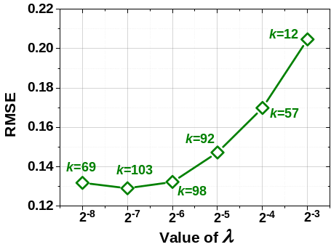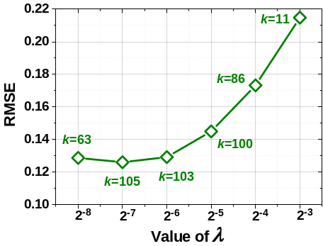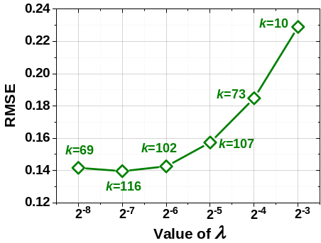
(a) D1. (b) D2. (c) D3.
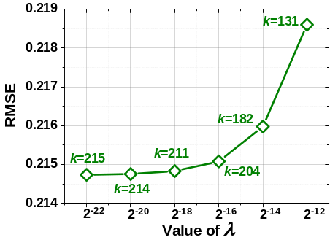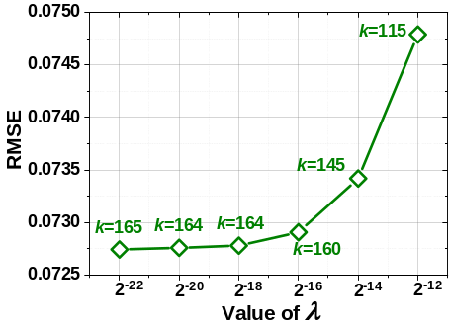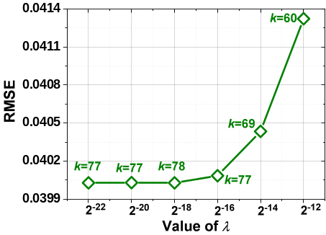
(d) D4. (e) D5. (f) D6.

Fig. S1. Sensitive experiments of λ in RSCN with fixed θ and η. (a)-(c) θ=2⁻⁵, η=0.2, (d) θ=2⁻⁴, η=0.6, (e) θ=2⁻⁵, η=0.2, and (f) θ=2⁻⁷, η=0.2.
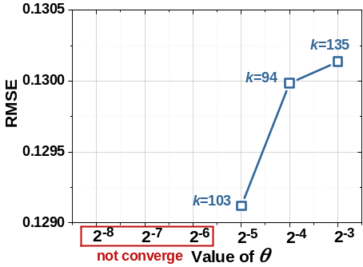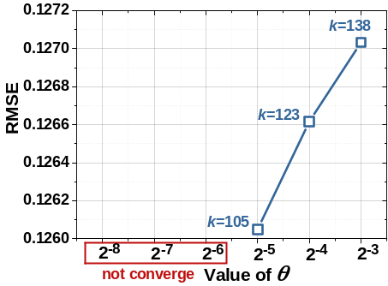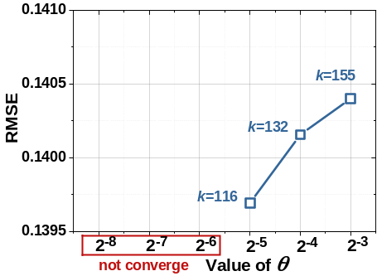
(a) D1. (b) D2. (c) D3.
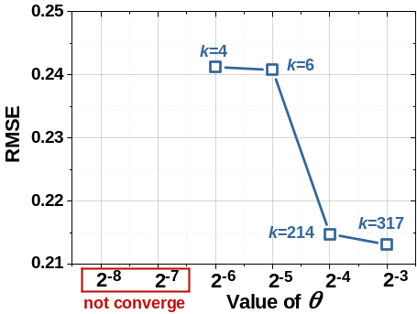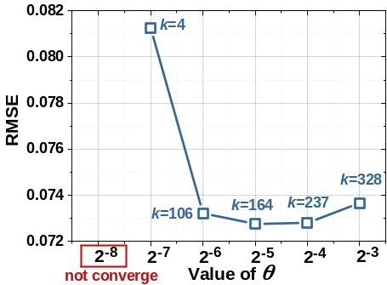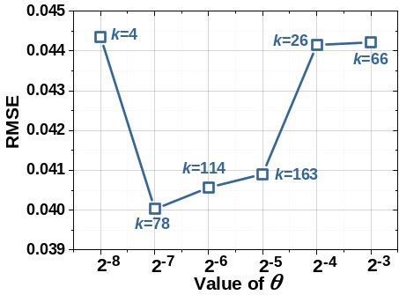
(d) D4. (e) D5. (f) D6.

Fig. S2. Sensitive experiments of θ in RSCN with fixed λ and η. (a)-(c) λ=2⁻⁷, η=0.2, (d) λ=2⁻²⁰, η=0.6, (e) λ=2⁻²⁰, η=0.2, and (f) λ=2⁻¹⁸, η=0.2.
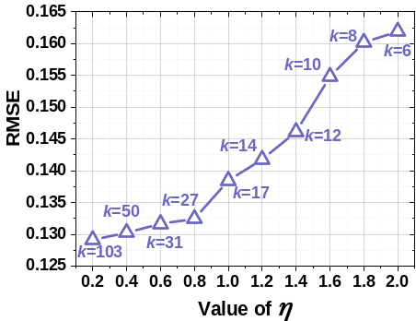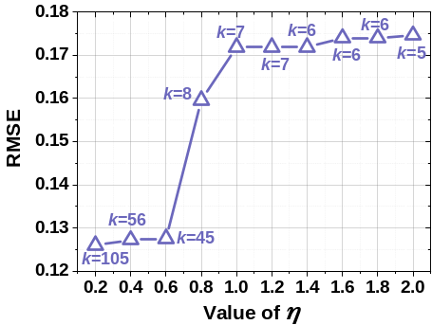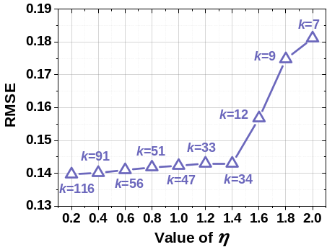
(a) D1. (b) D2. (c) D3.
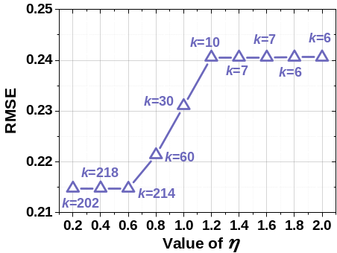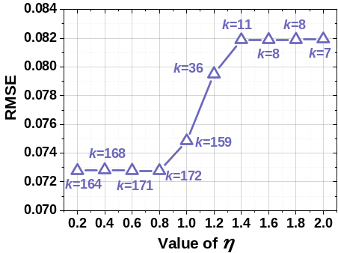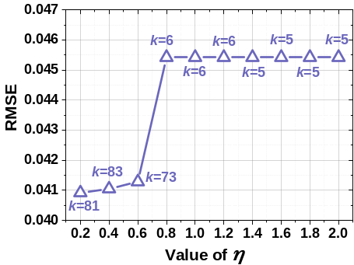
(d) D4. (e) D5. (f) D6.

Fig. S3. Sensitive experiments of η in RSCN with fixed λ and θ. (a)-(c) λ=2⁻⁷, θ=2⁻⁵, (d) λ=2⁻²⁰, θ=2⁻⁴, (e) λ=2⁻²⁰, θ=2⁻⁵, and (f) λ=2⁻¹⁸, θ=2⁻⁷.

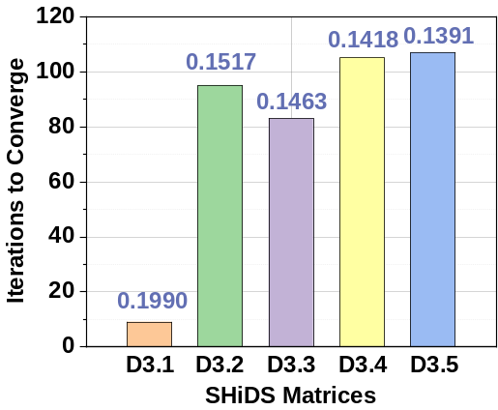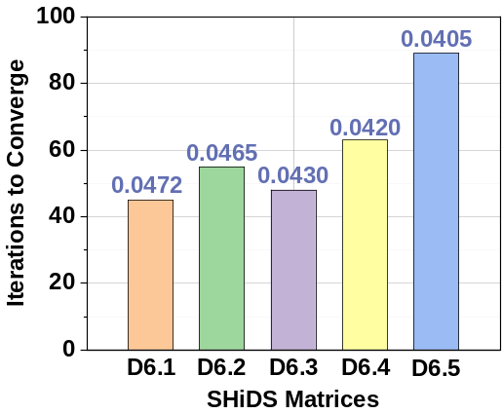
(a) (b)

Fig. S4. RSCN’s Performance on D3 and D6 as data density varies.

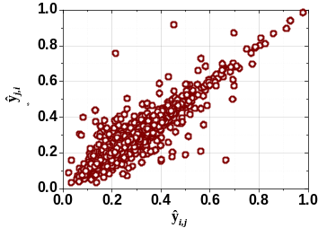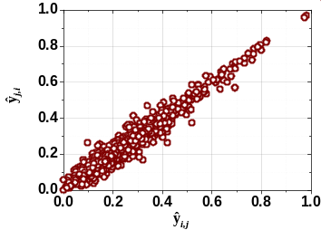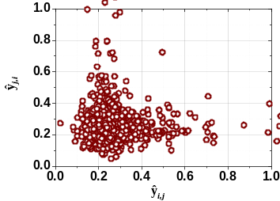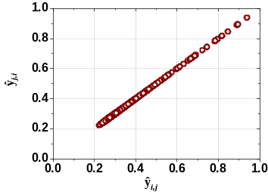
(a) M1 (b) M2 (c) M3 (d) M4

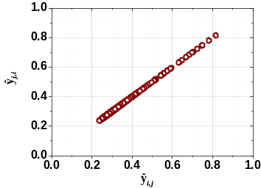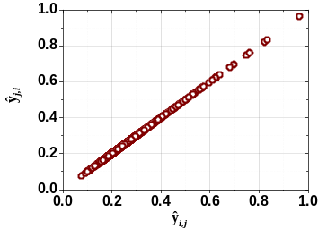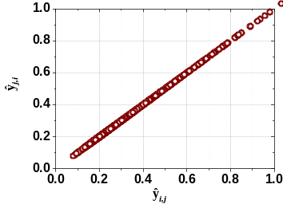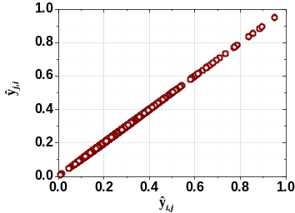
(e) M5 (f) M6 (g) M7 (h) M8

Fig. S5. Symmetric representation of M1-8 on D1.

